第三章 虚拟内存管理(3.2)

知识点：

页表机制：
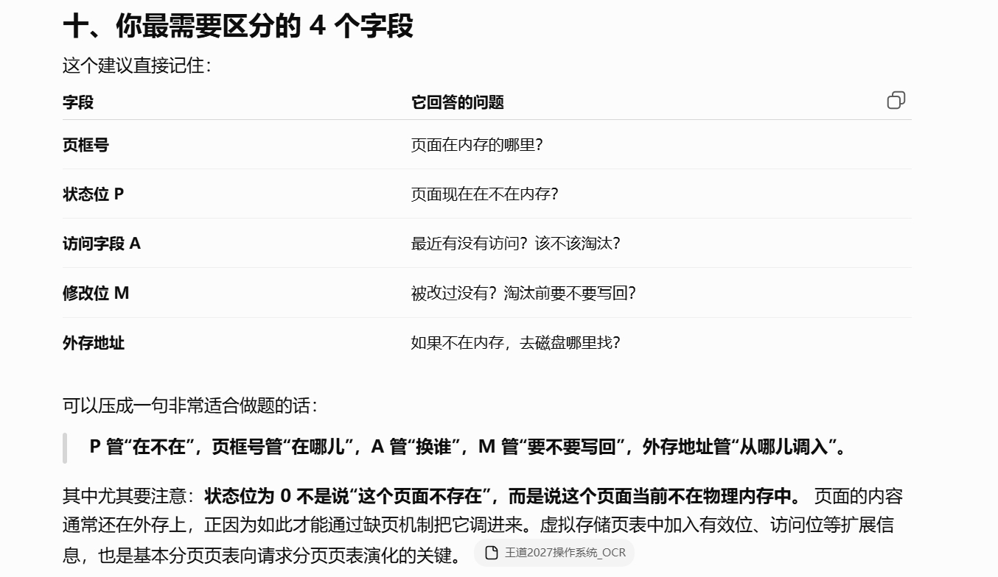
https://chatgpt.com/g/g-p-6a4147b6a8088191bef869eb87bbe5c0-cao-zuo-xi-tong/c/6a7f011d-1298-83ee-a352-1e307201a475

内存分配策略：
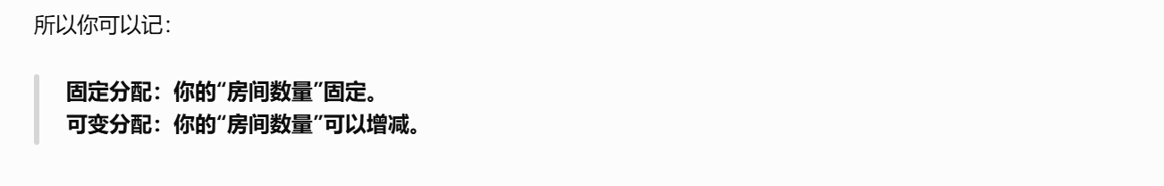
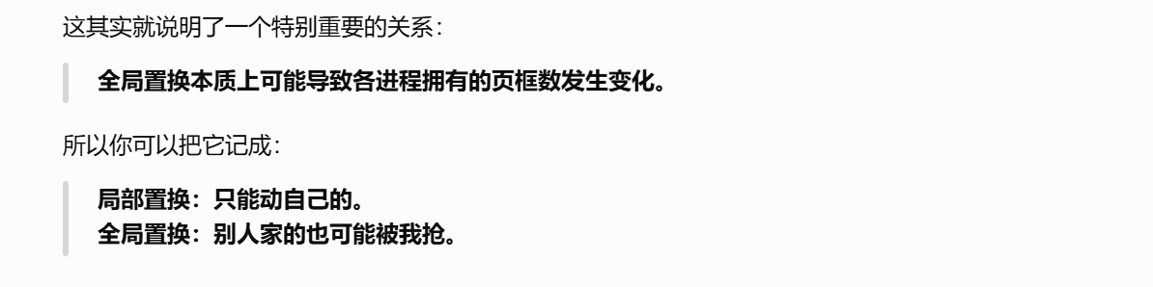
https://chatgpt.com/g/g-p-6a4147b6a8088191bef869eb87bbe5c0-cao-zuo-xi-tong/c/6a7f091d-459c-83e8-90d1-489250a36fdf

3.2.9地址翻译的示例：
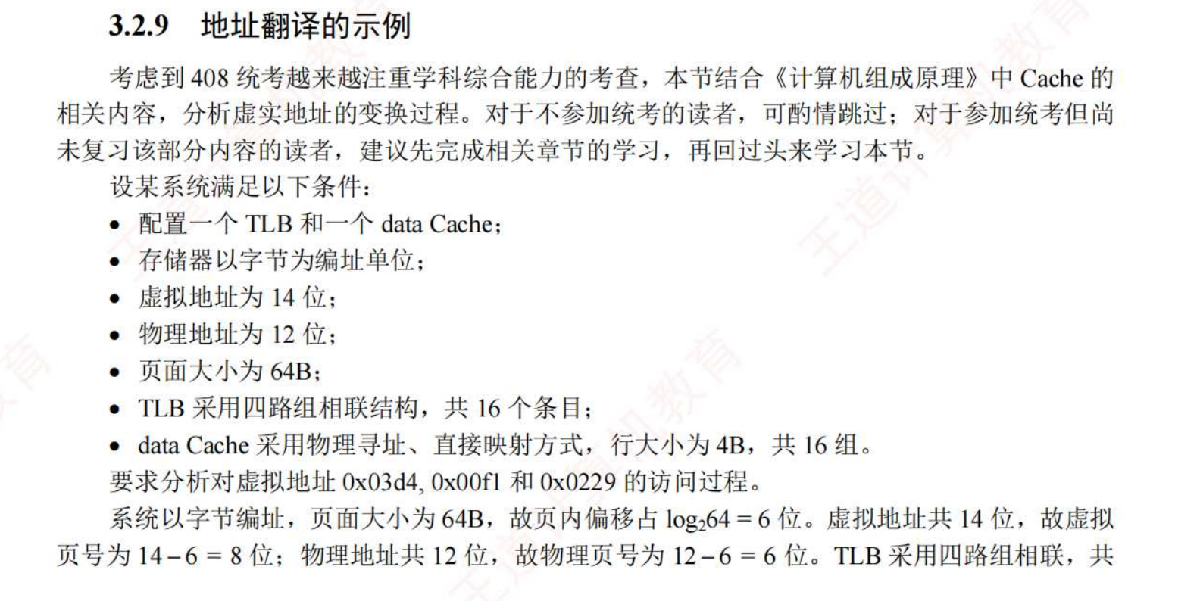
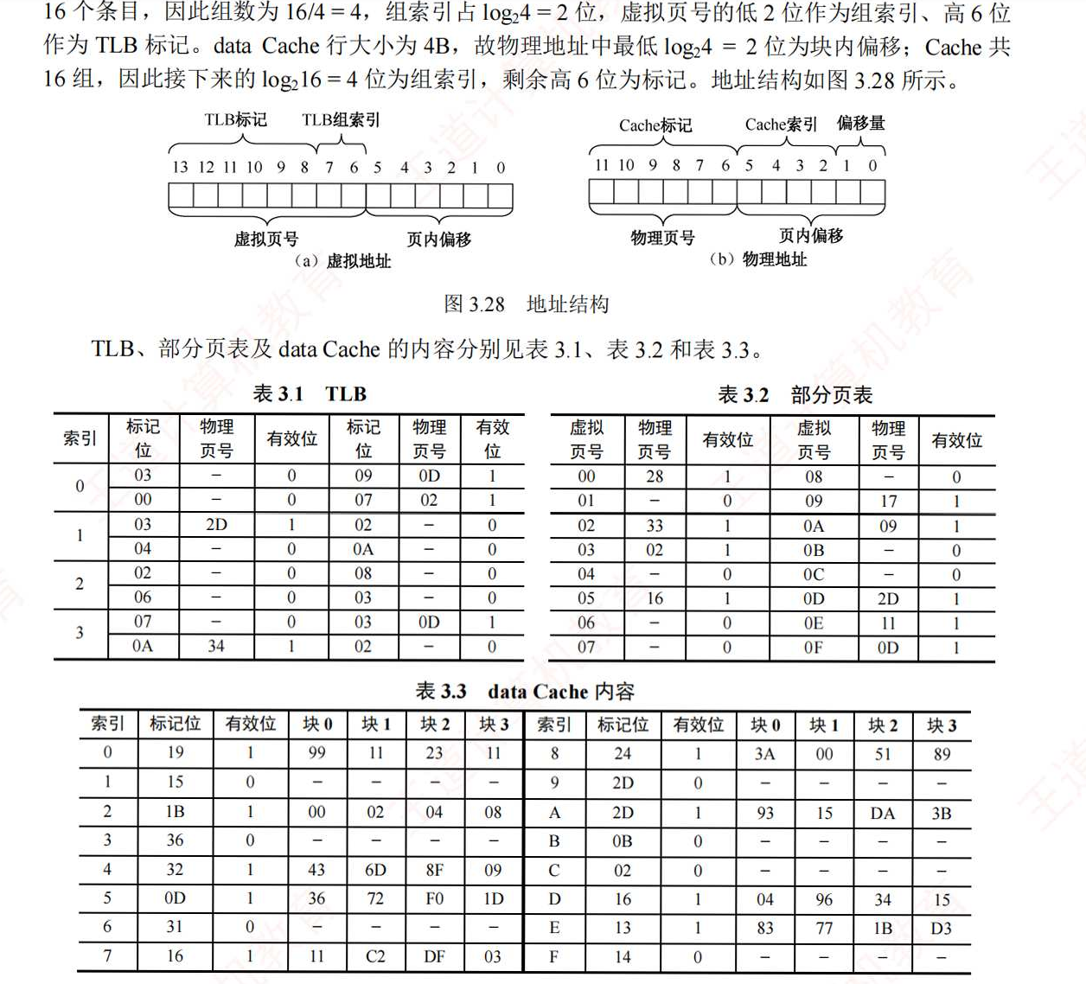
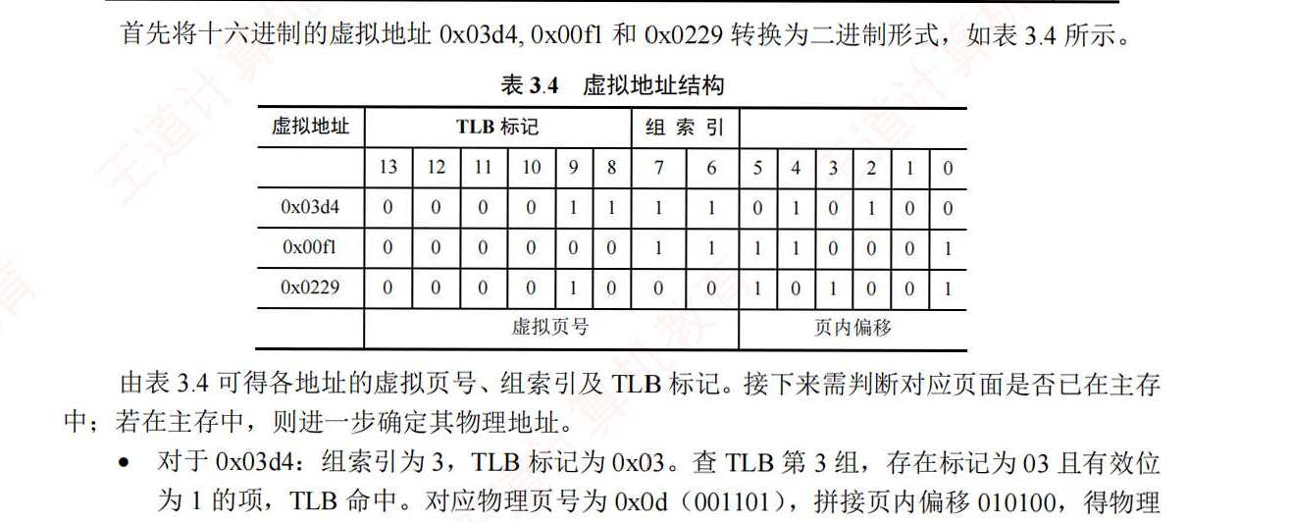
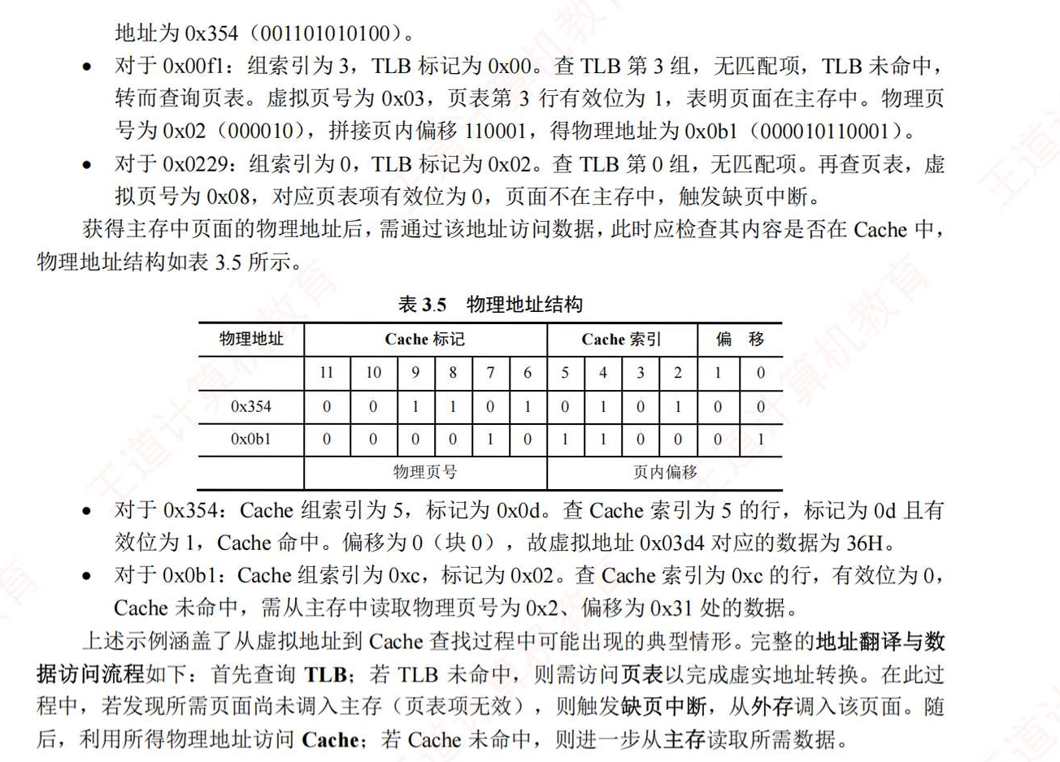

概念：

驻留集：
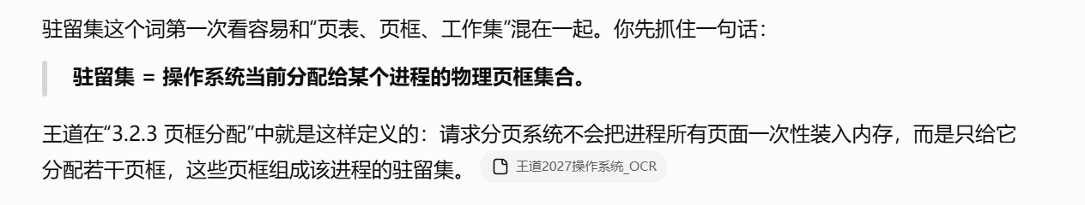
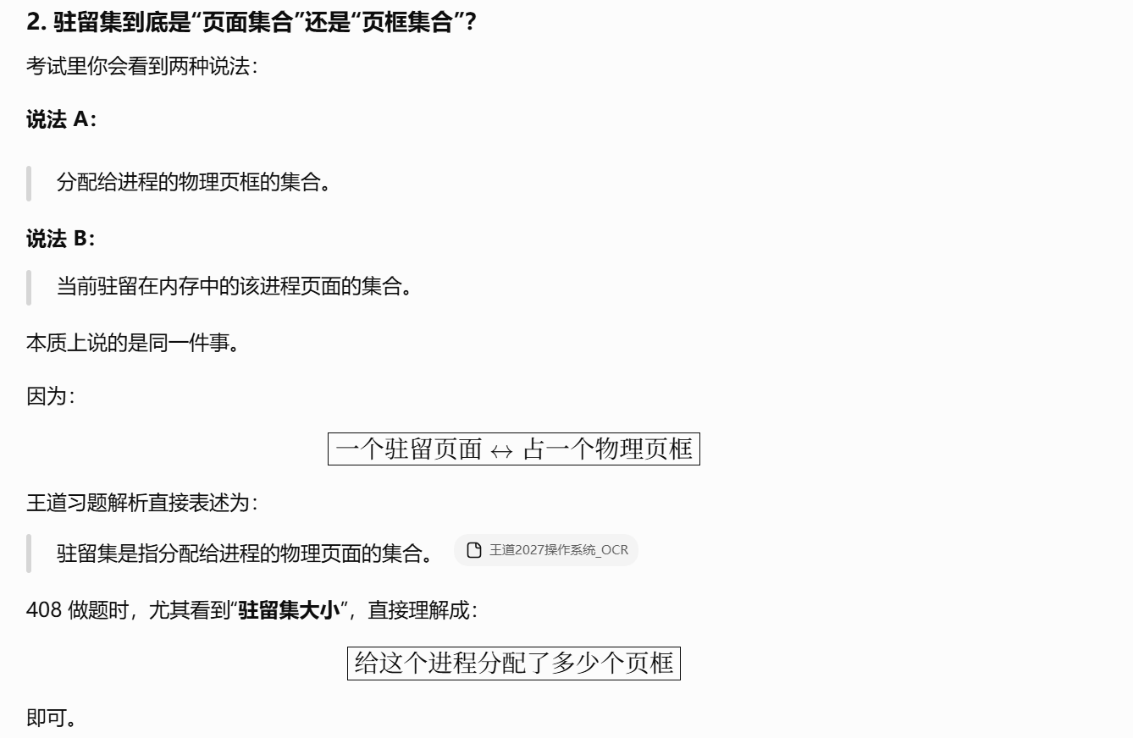
https://chatgpt.com/g/g-p-6a4147b6a8088191bef869eb87bbe5c0-cao-zuo-xi-tong/c/6a7f0bfa-3dd4-83ee-b250-945c9c5455be

工作集：
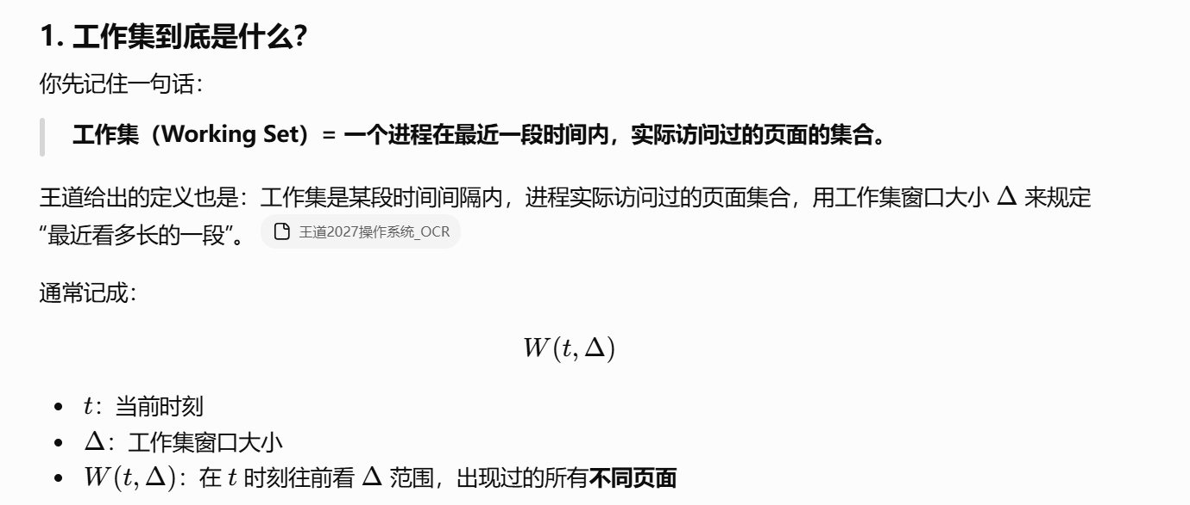
https://chatgpt.com/g/g-p-6a4147b6a8088191bef869eb87bbe5c0-cao-zuo-xi-tong/c/6a82fb44-e704-83e8-aafe-e910b9b25bf5
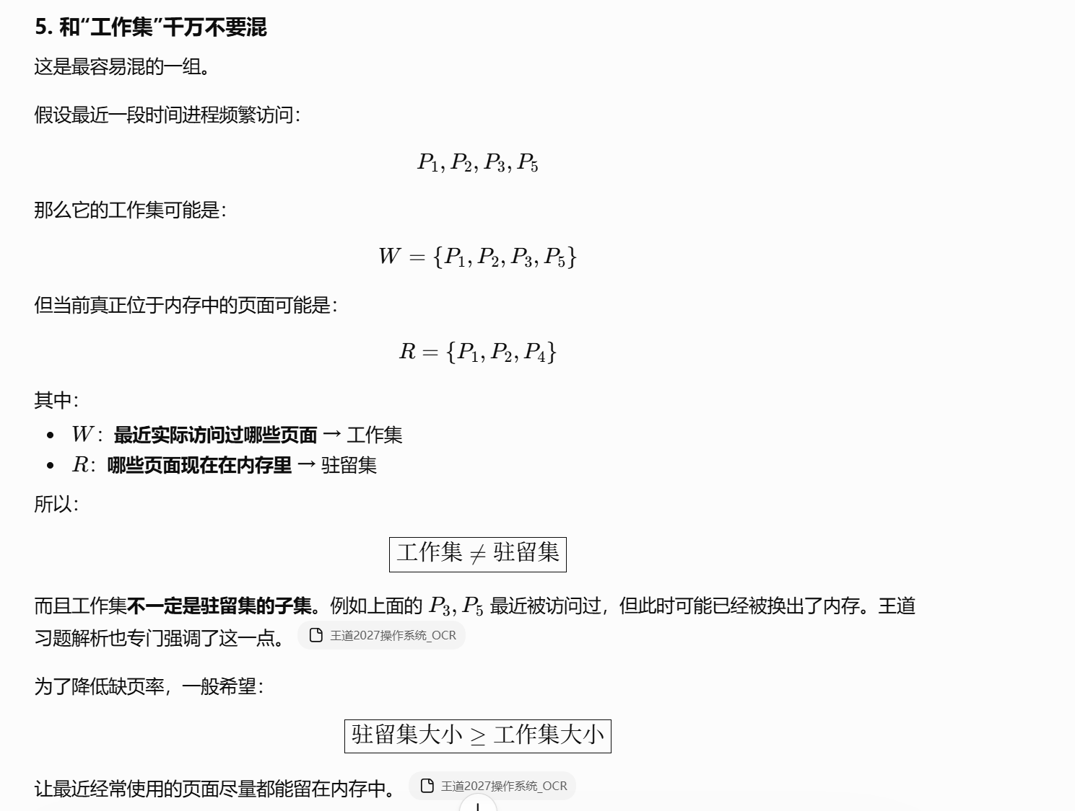

引用串长度：
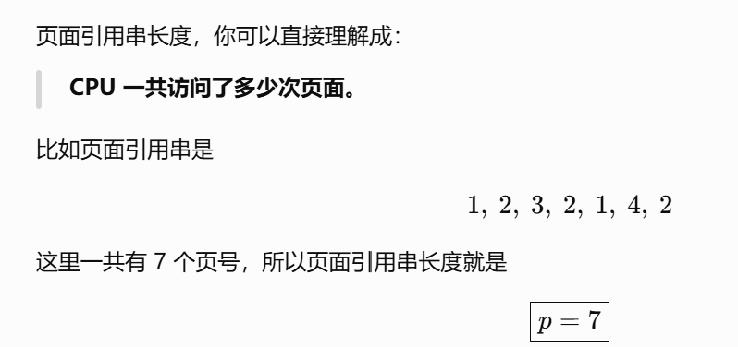

页表项：
https://chatgpt.com/g/g-p-6a4147b6a8088191bef869eb87bbe5c0-cao-zuo-xi-tong/c/6a814a8f-bc40-83e8-8e5a-e31ffdd782f3

TLB条目：
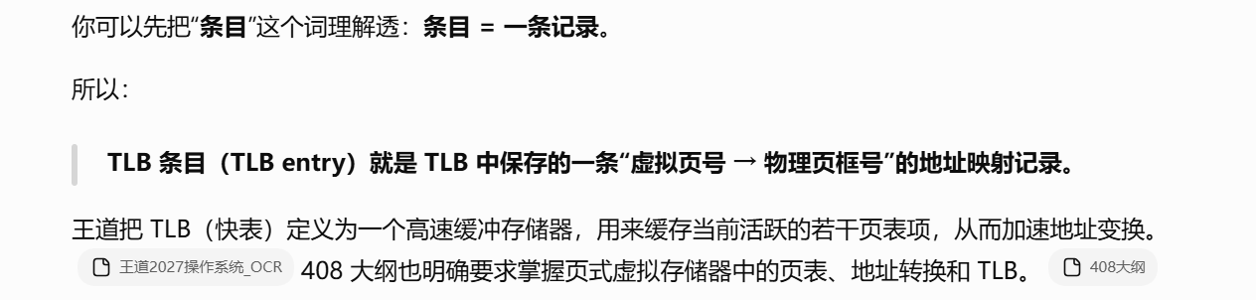
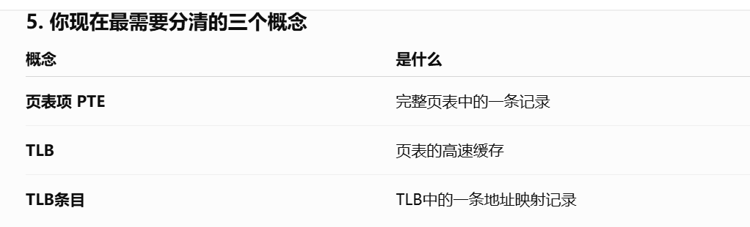
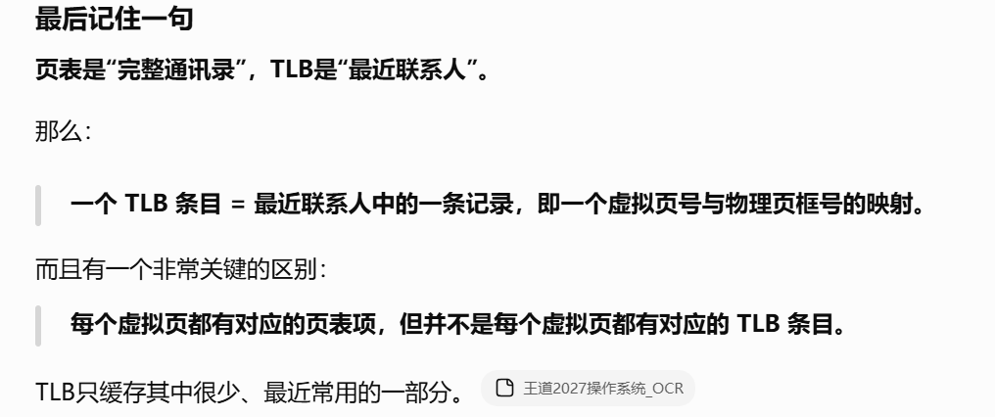
https://chatgpt.com/g/g-p-6a4147b6a8088191bef869eb87bbe5c0-cao-zuo-xi-tong/c/6a814f91-4748-83ee-886b-f9bcd02de6c7

Problems:

指令执行引发中断：
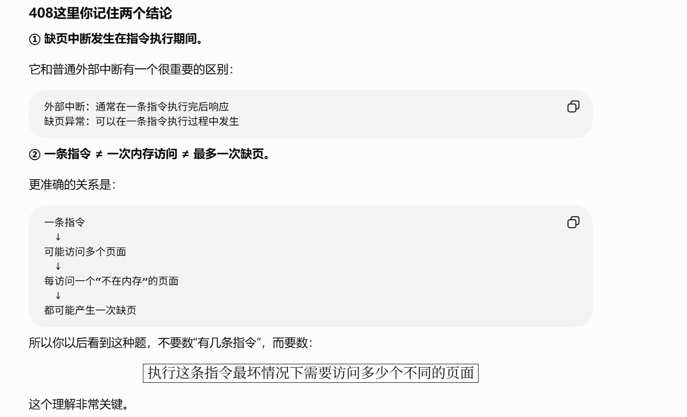
https://chatgpt.com/g/g-p-6a4147b6a8088191bef869eb87bbe5c0-cao-zuo-xi-tong/c/6a7f02dd-bedc-83ee-9fe4-16ab580801b4

关于地址的计算题(*):
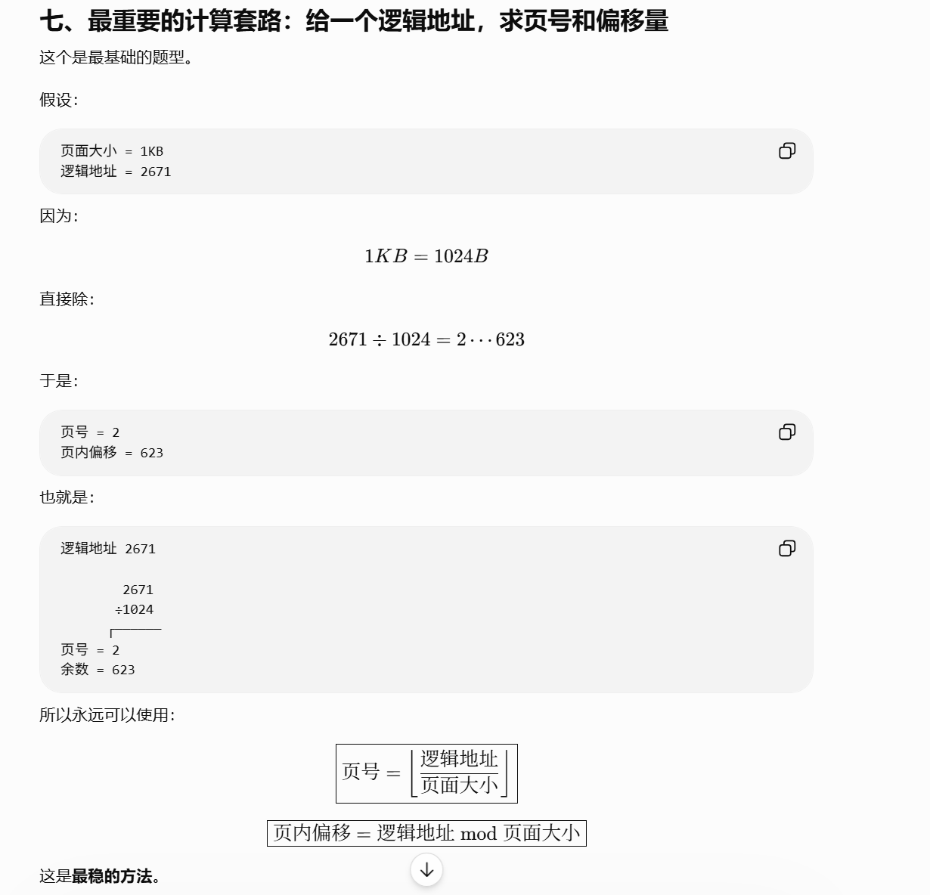
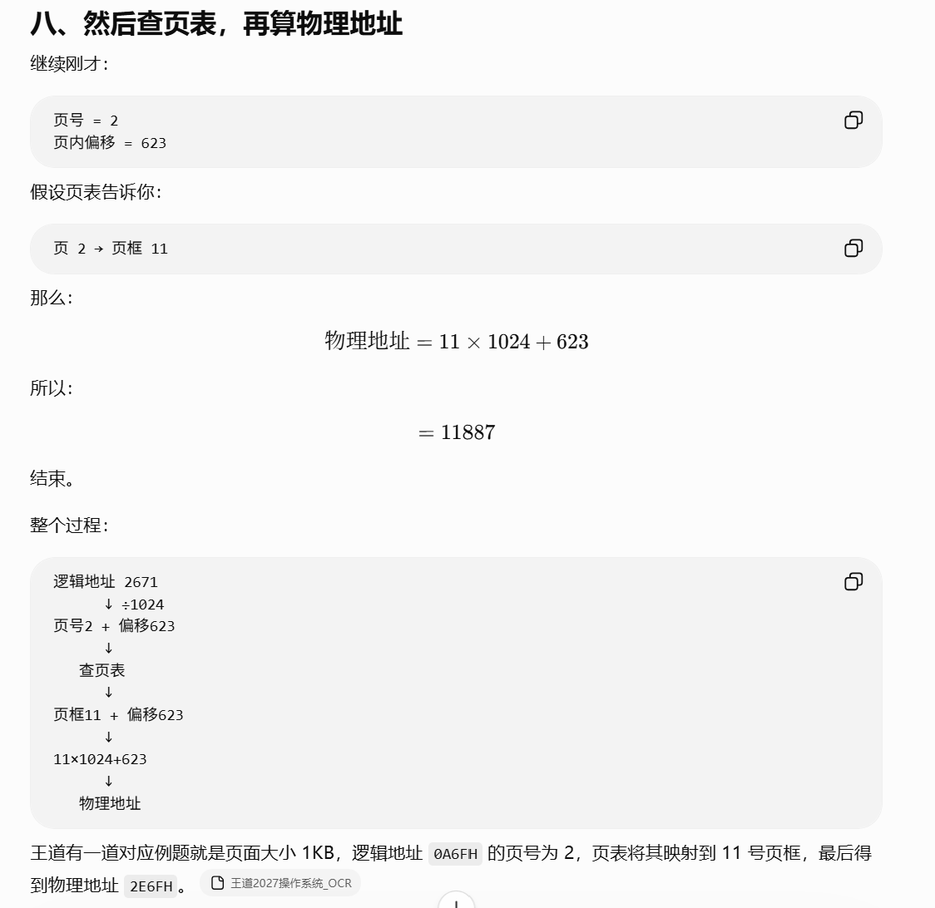
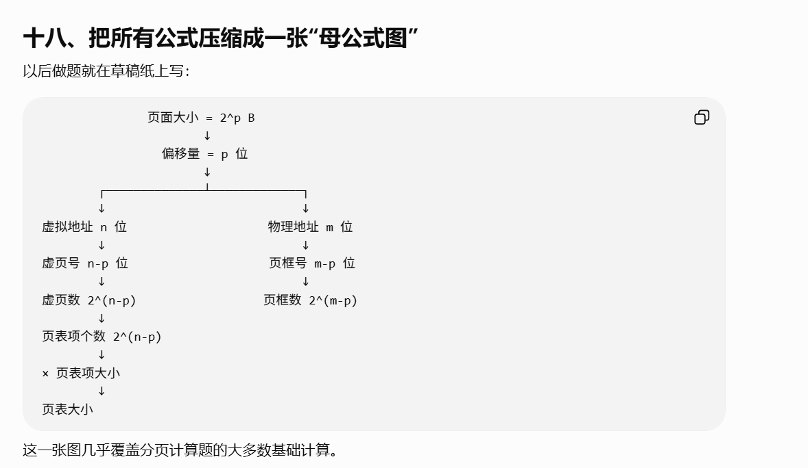
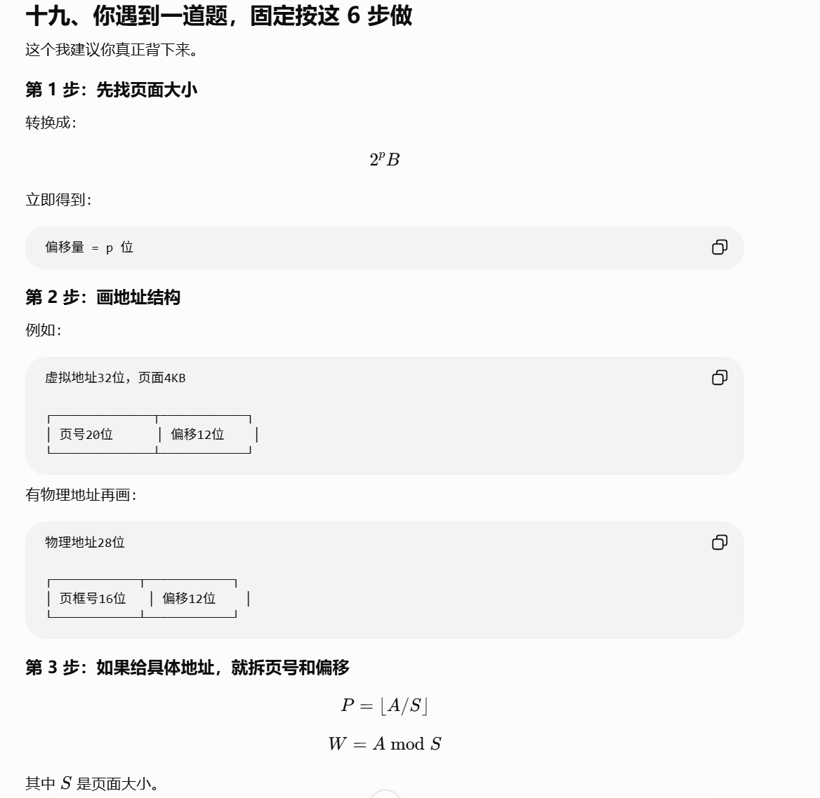
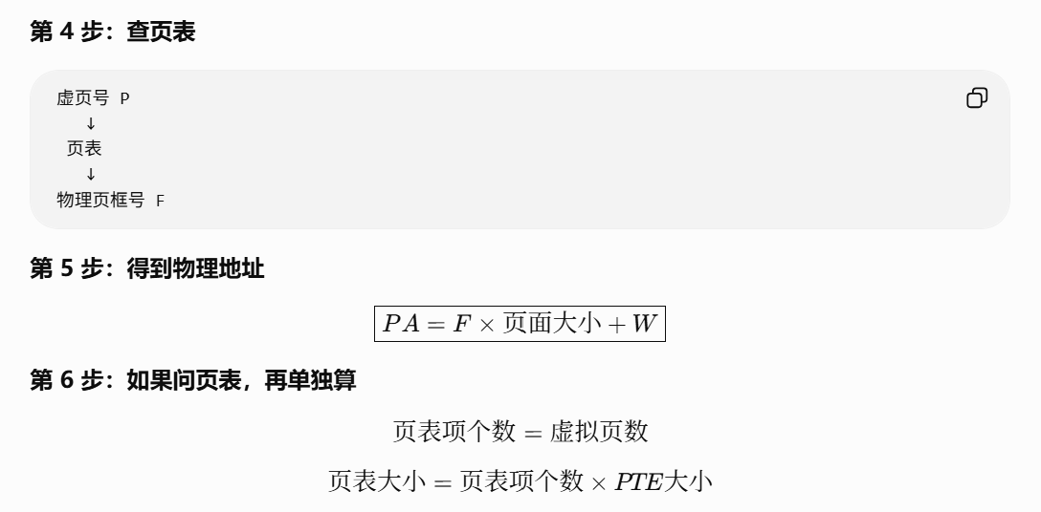
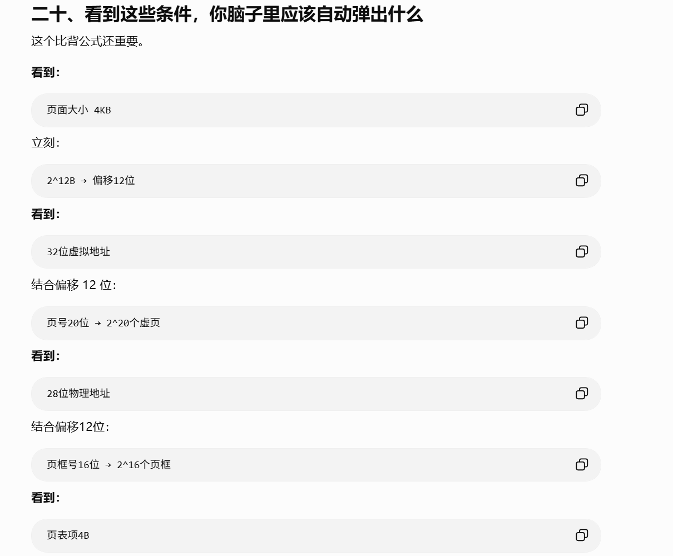
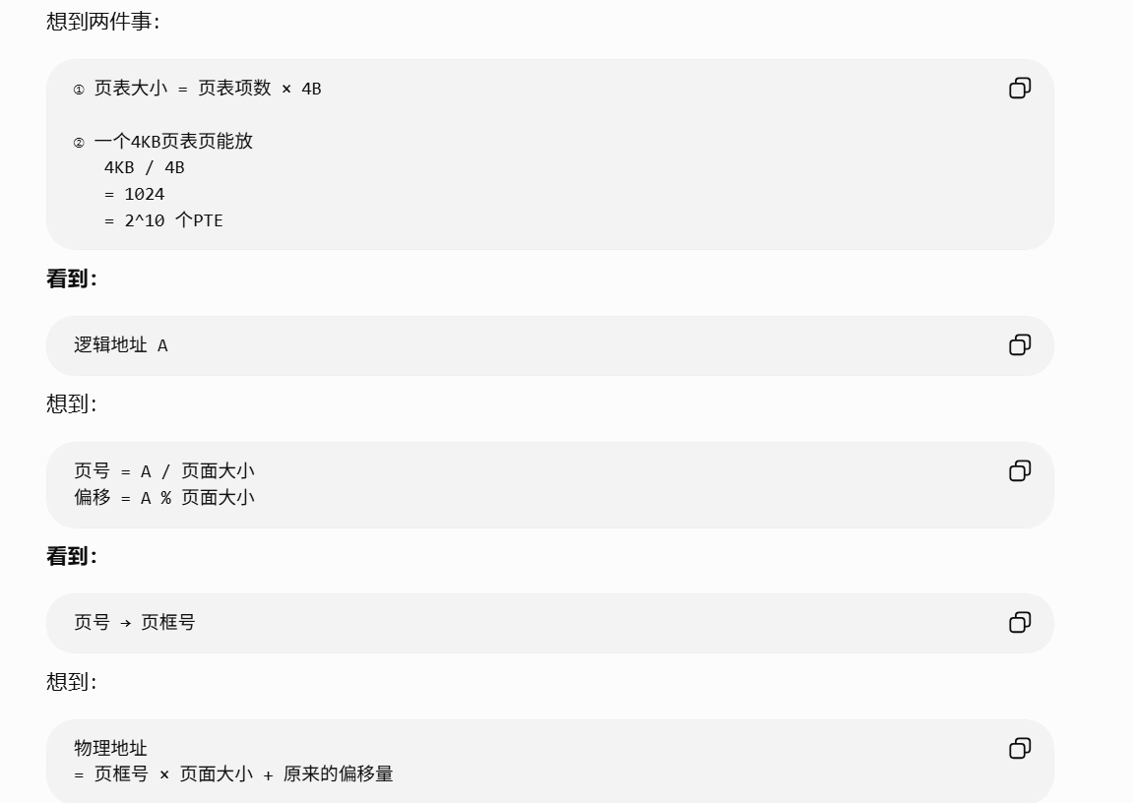
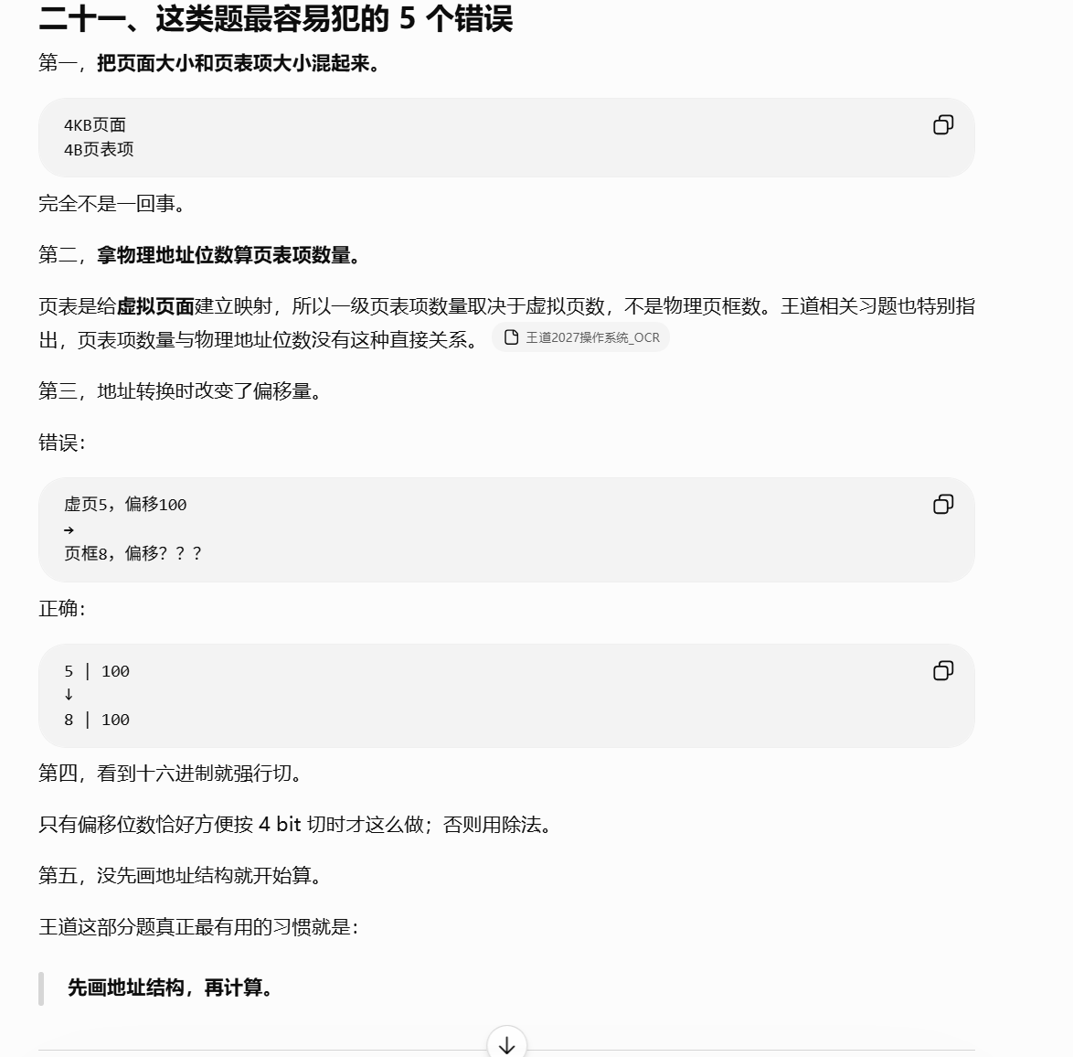
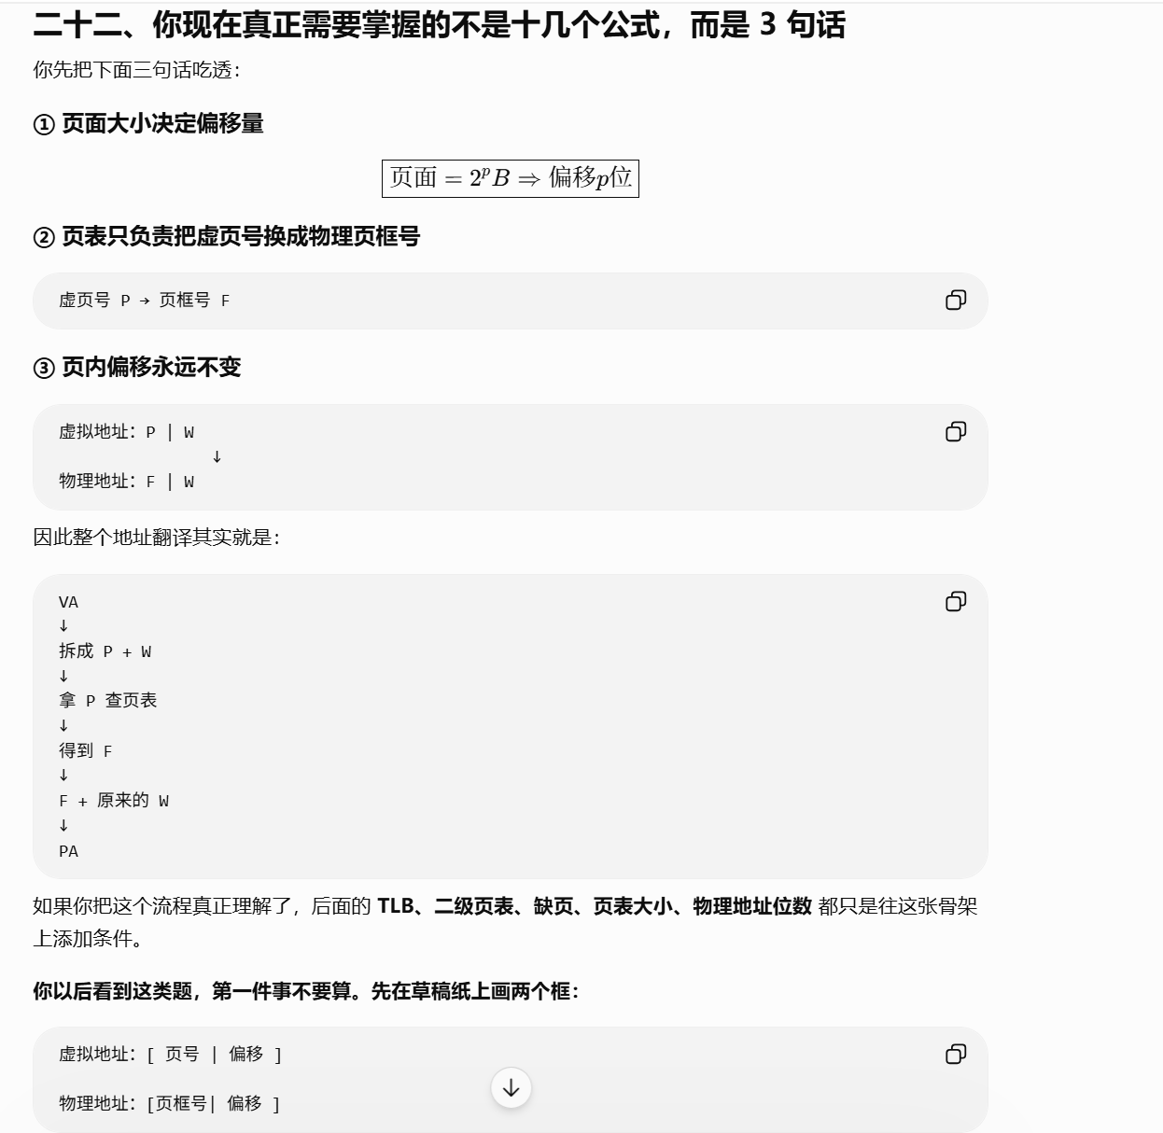
https://chatgpt.com/g/g-p-6a4147b6a8088191bef869eb87bbe5c0-cao-zuo-xi-tong/c/6a813fbf-4064-83e8-a81c-90b25d370788

URL:

3.2：
https://chatgpt.com/g/g-p-6a4147b6a8088191bef869eb87bbe5c0-cao-zuo-xi-tong/c/6a7efcda-c10c-83ee-a45a-eeff124e4ca2

clock算法：
https://chatgpt.com/g/g-p-6a4147b6a8088191bef869eb87bbe5c0-cao-zuo-xi-tong/c/6a806205-8bc8-83ee-8fbf-44c779c470da

3.2.7～3.2.9：
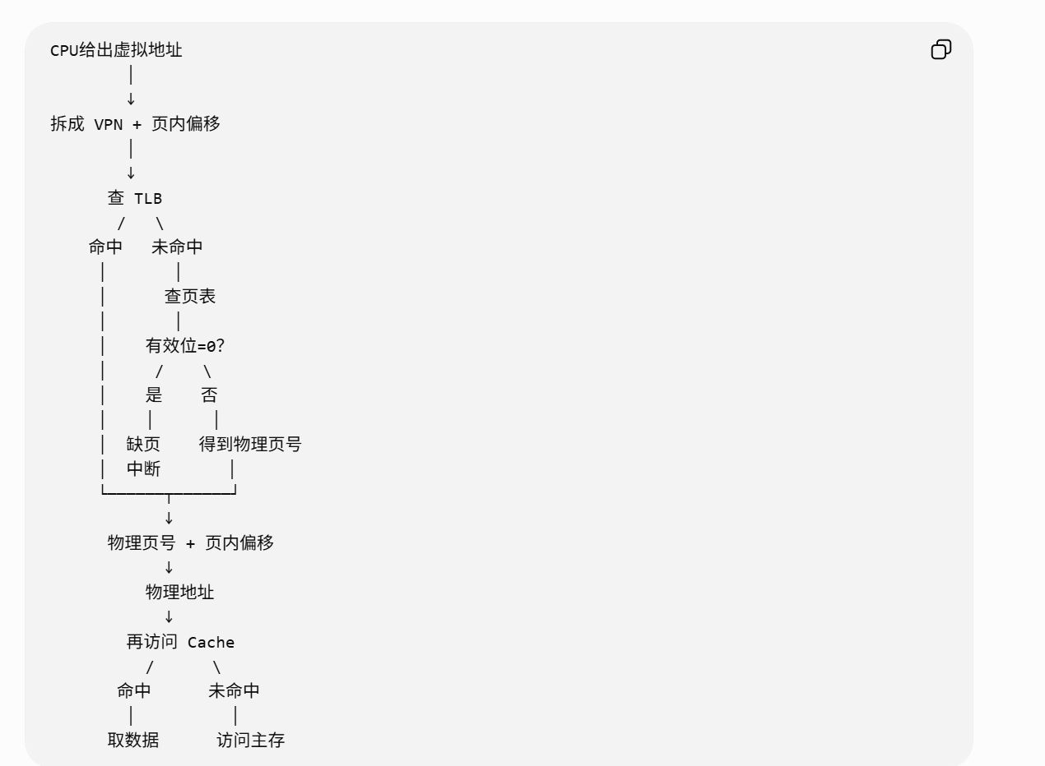
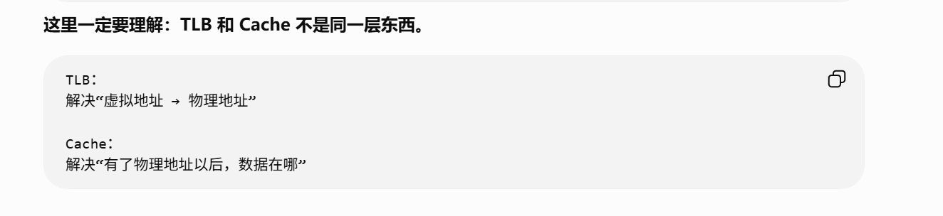
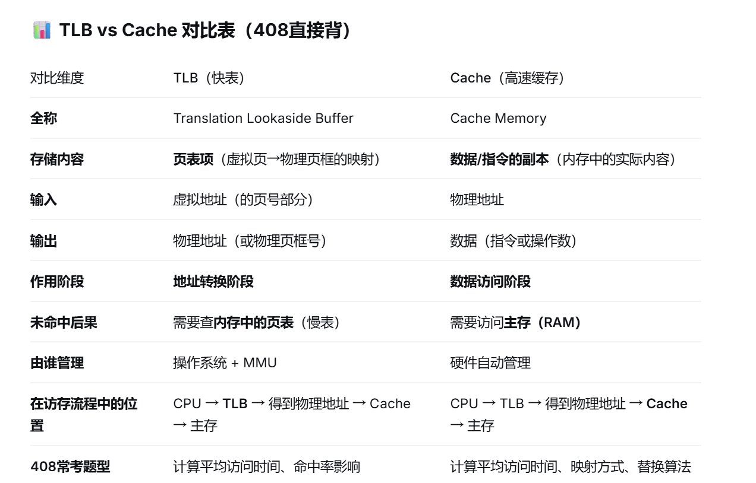

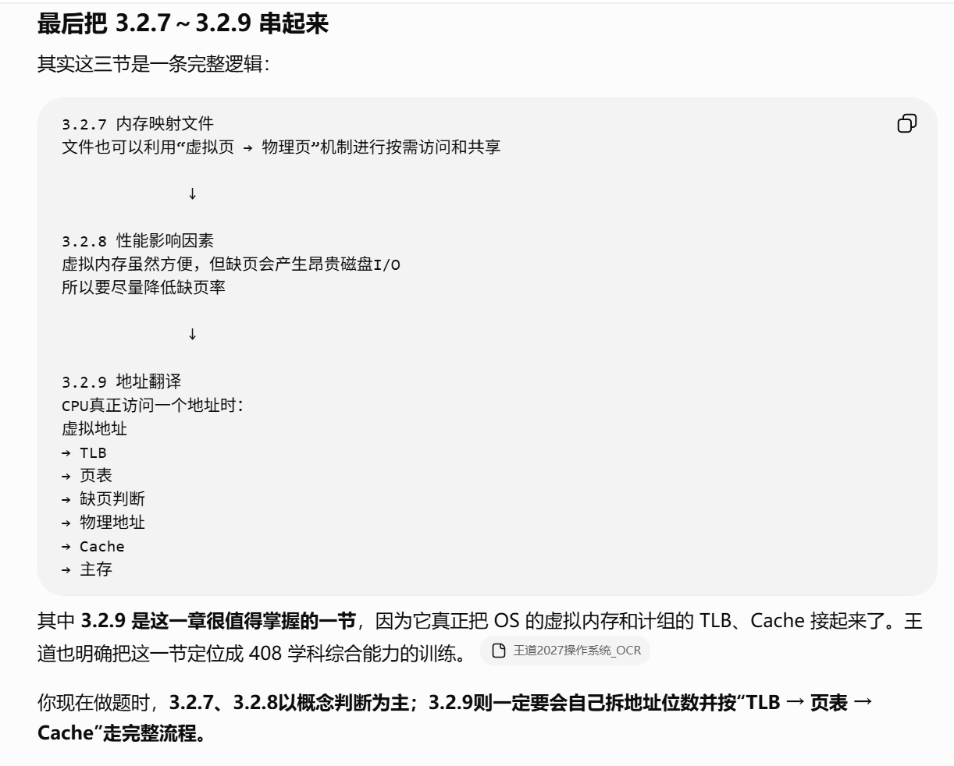
https://chatgpt.com/g/g-p-6a4147b6a8088191bef869eb87bbe5c0-cao-zuo-xi-tong/c/6a811d9d-4510-83e8-95b1-68094a865164

题：

题1：
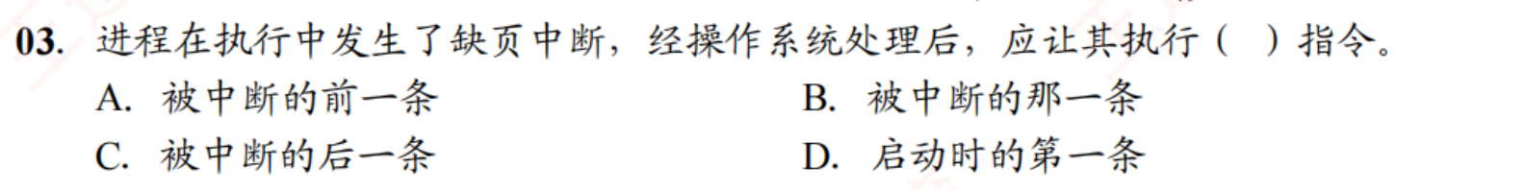
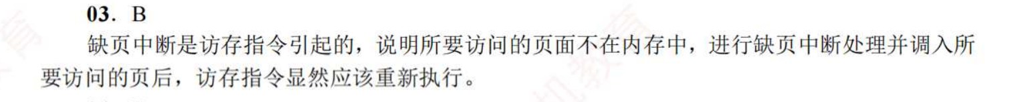

题2：
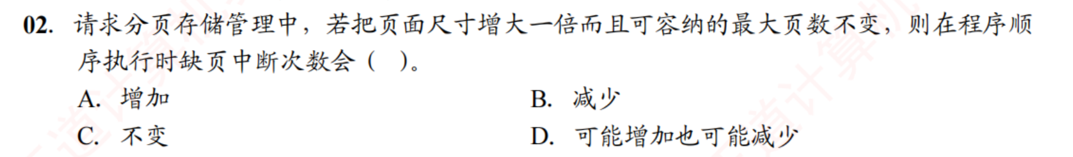
https://chatgpt.com/g/g-p-6a4147b6a8088191bef869eb87bbe5c0-cao-zuo-xi-tong/c/6a7f16b7-f7f0-83e8-844e-5e94c84dc51f

题3：
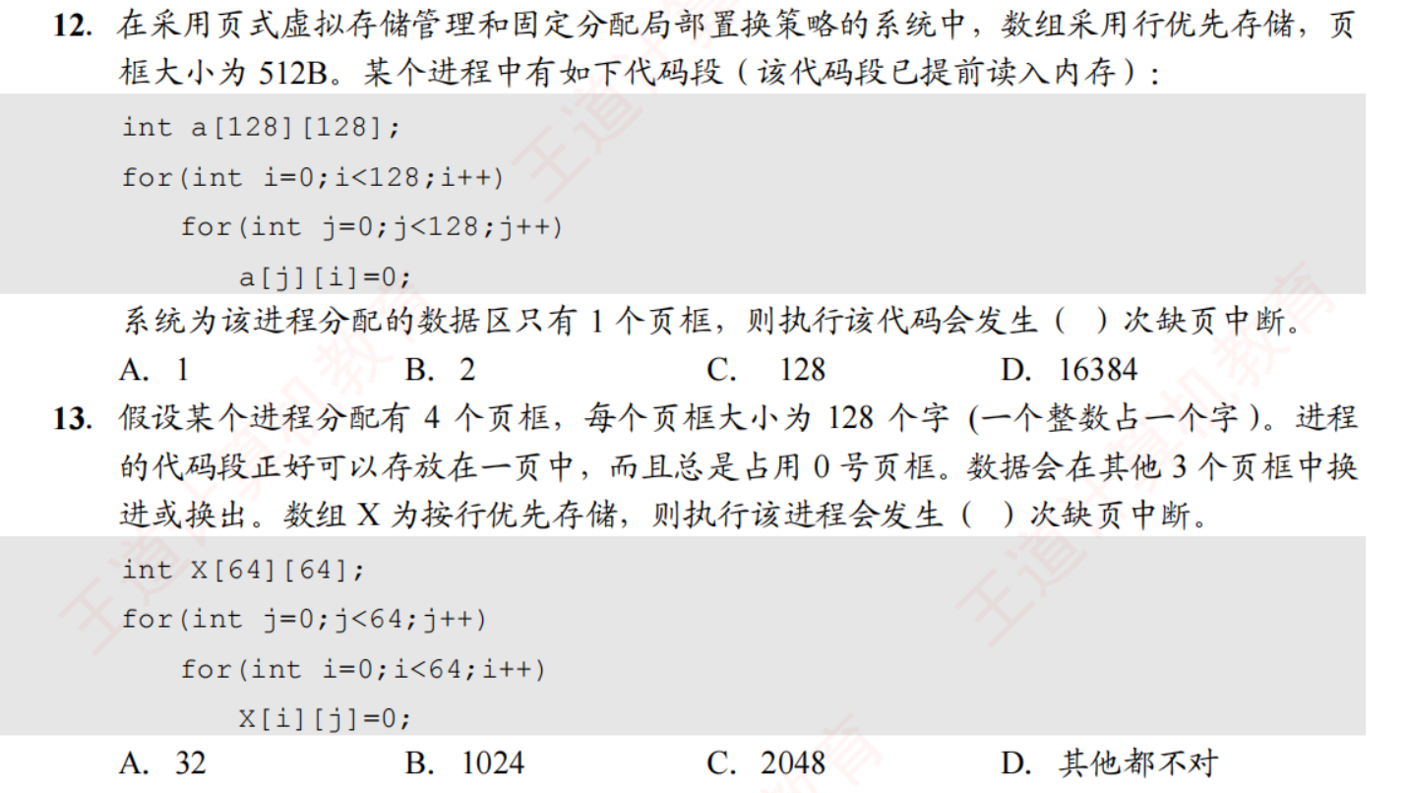
https://chatgpt.com/g/g-p-6a4147b6a8088191bef869eb87bbe5c0-cao-zuo-xi-tong/c/6a81391f-287c-83ee-8285-38ecd776df7b

题4：
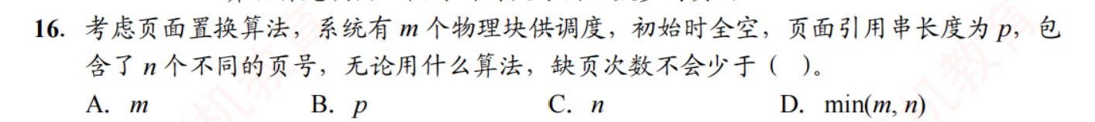
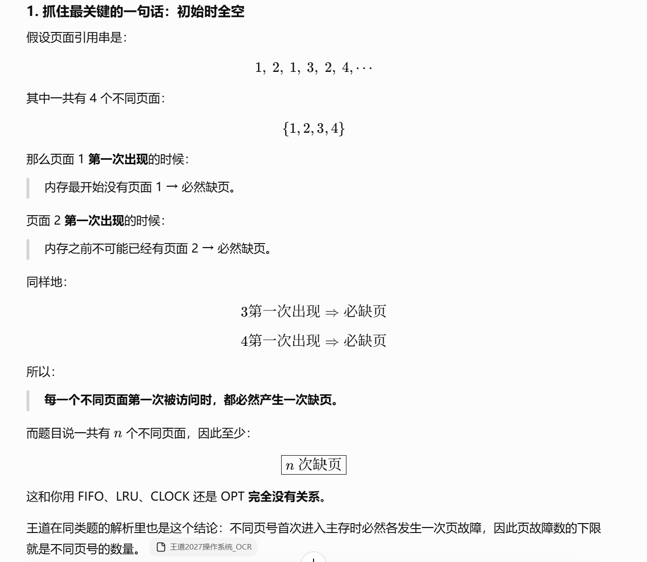
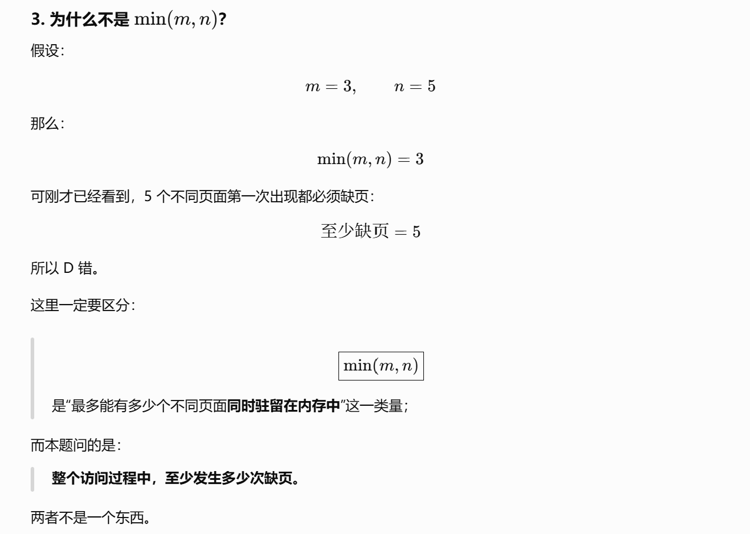
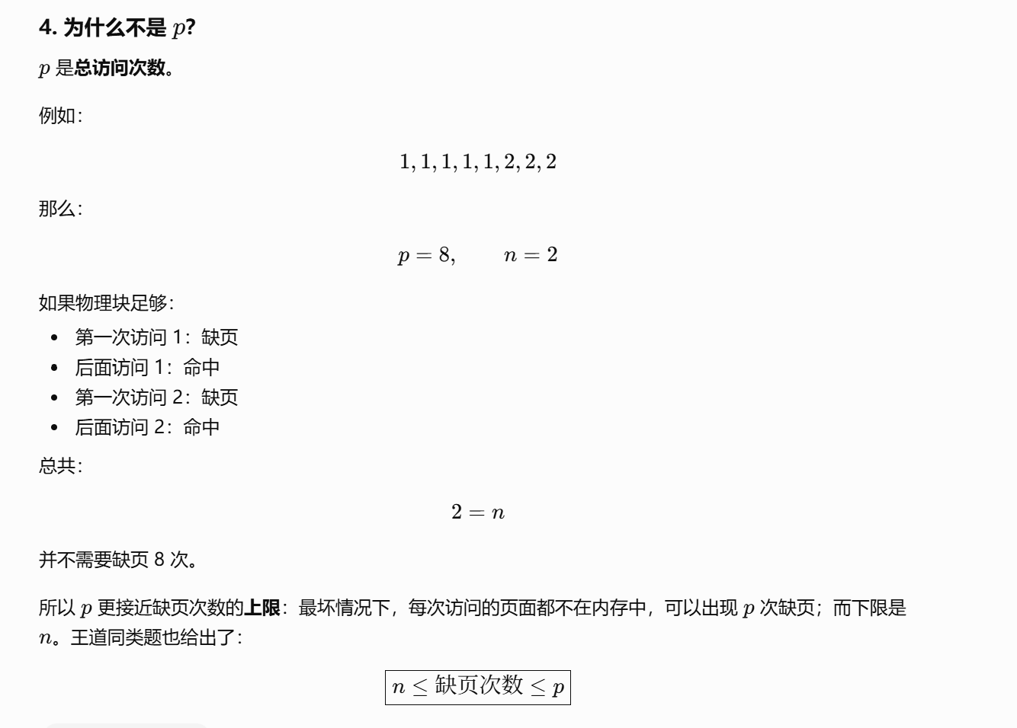
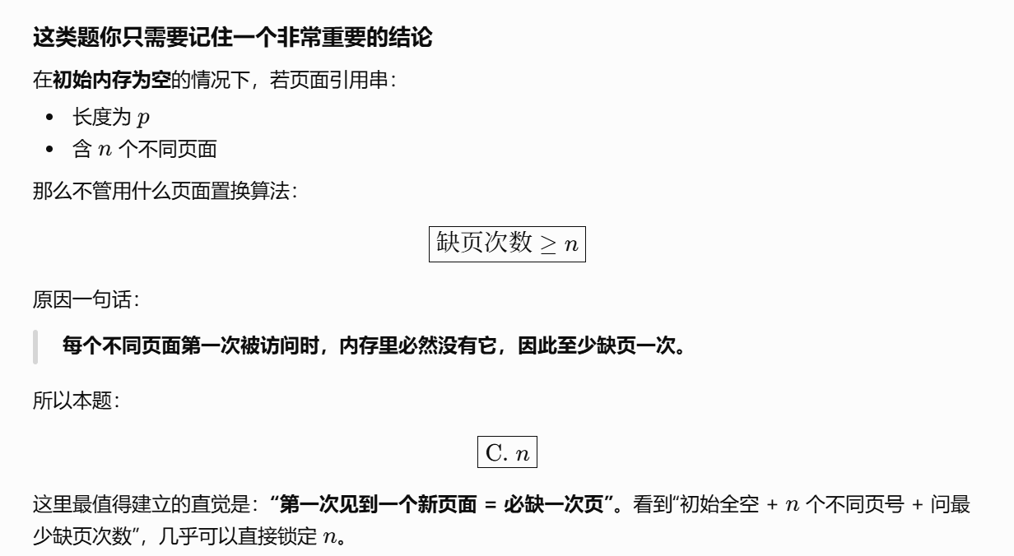
https://chatgpt.com/g/g-p-6a4147b6a8088191bef869eb87bbe5c0-cao-zuo-xi-tong/c/6a813f1d-2730-83ee-a55c-8e19ccefe6e1

题5：TLB命中率
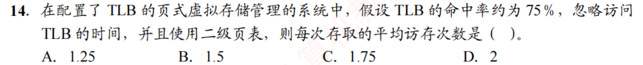
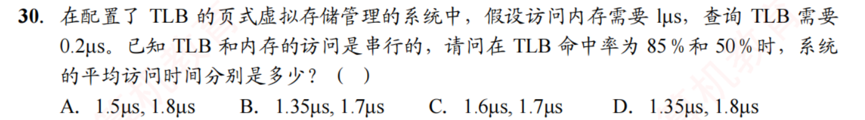
https://chatgpt.com/g/g-p-6a4147b6a8088191bef869eb87bbe5c0-cao-zuo-xi-tong/c/6a813f46-3ddc-83ee-9186-276fda5a173c

题6：计算
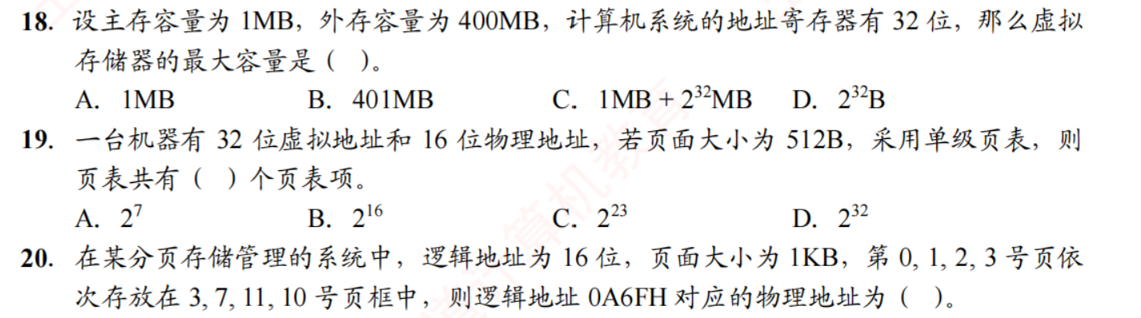
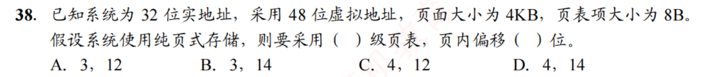
https://chatgpt.com/g/g-p-6a4147b6a8088191bef869eb87bbe5c0-cao-zuo-xi-tong/c/6a814992-69f4-83e8-ade3-b71a6a121f74

题7：概念
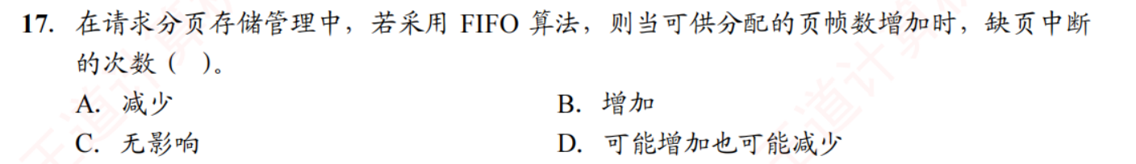
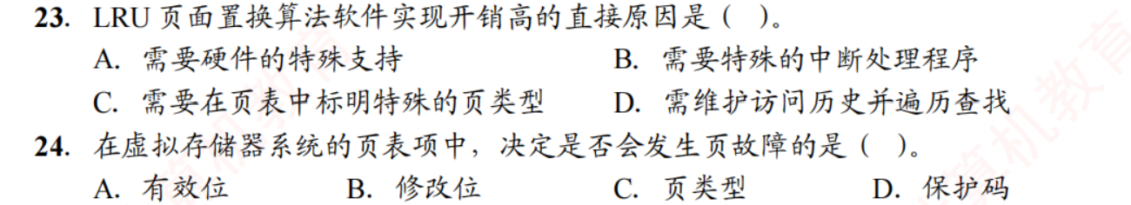
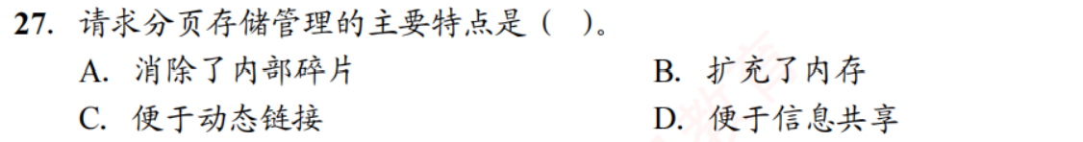
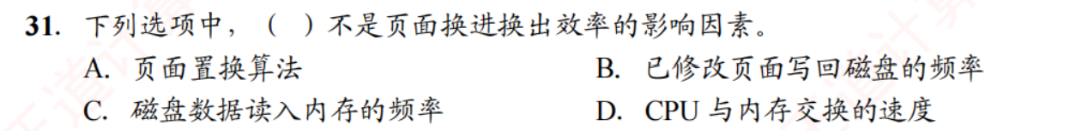
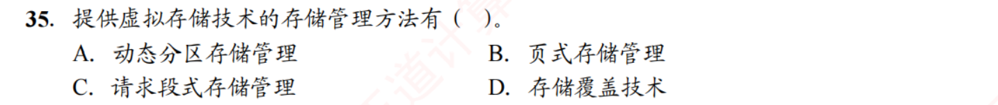
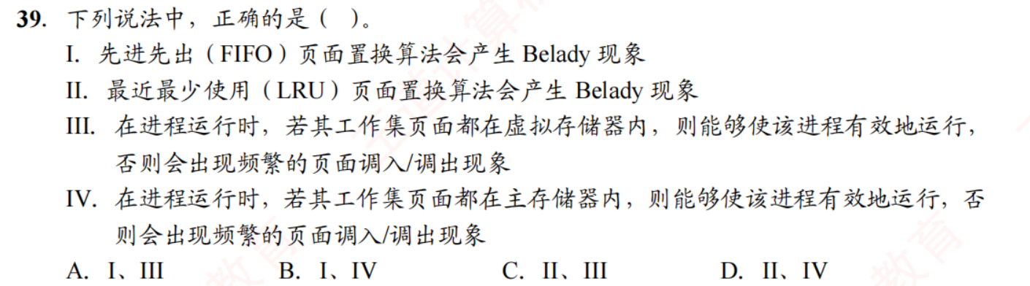
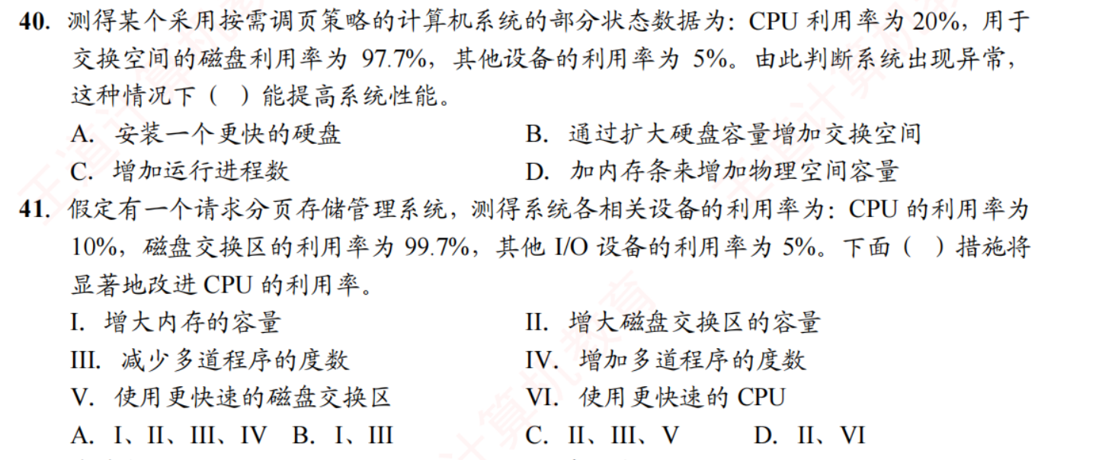
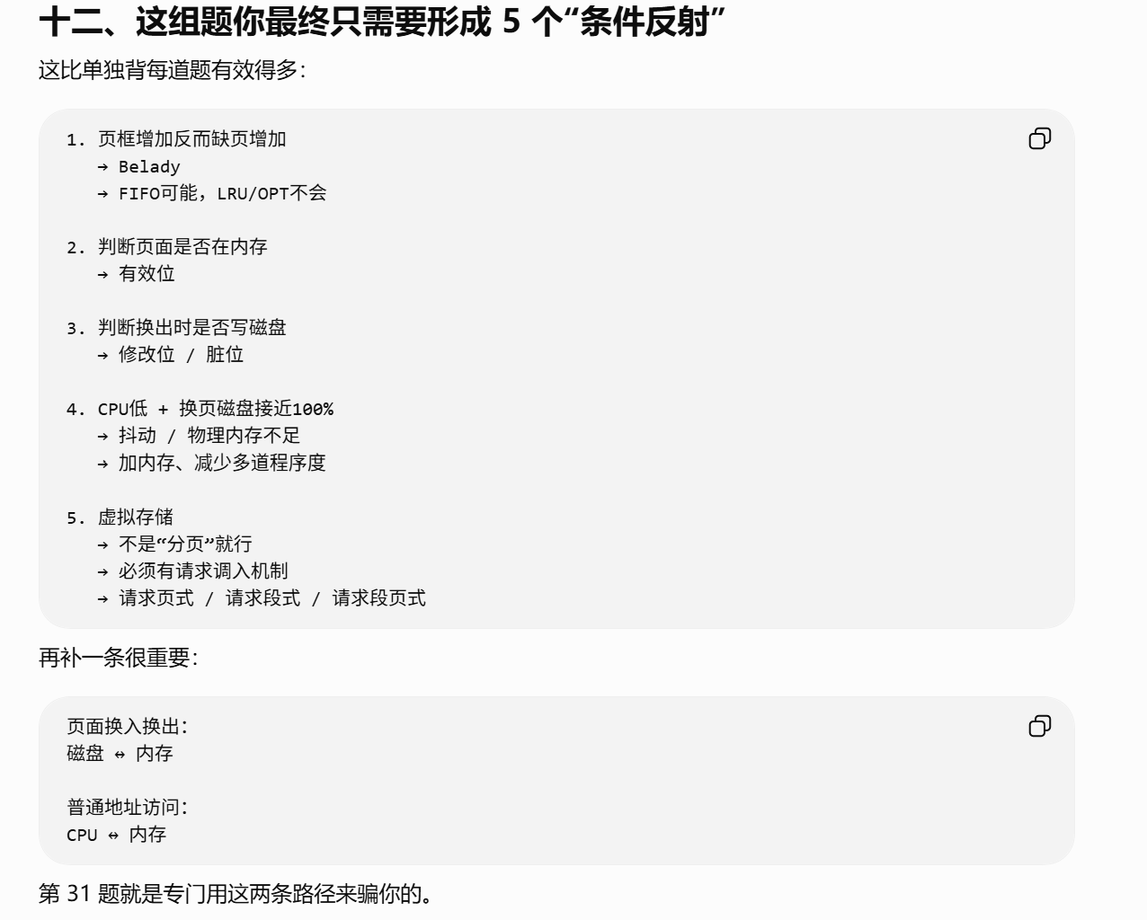
https://chatgpt.com/g/g-p-6a4147b6a8088191bef869eb87bbe5c0-cao-zuo-xi-tong/c/6a814d83-98f8-83e8-9d00-4f47334dc364

题8：真题

概念：
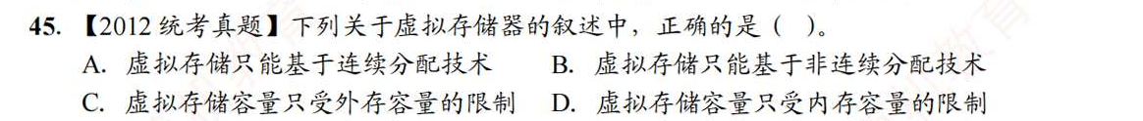

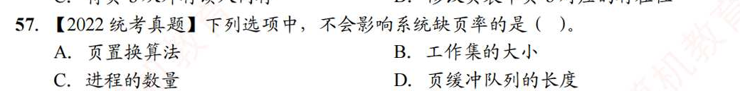

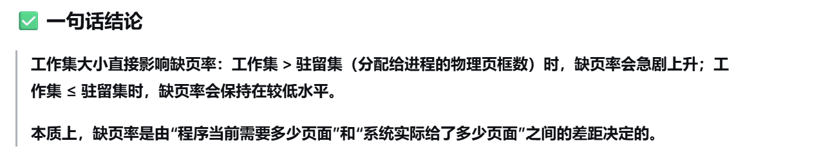
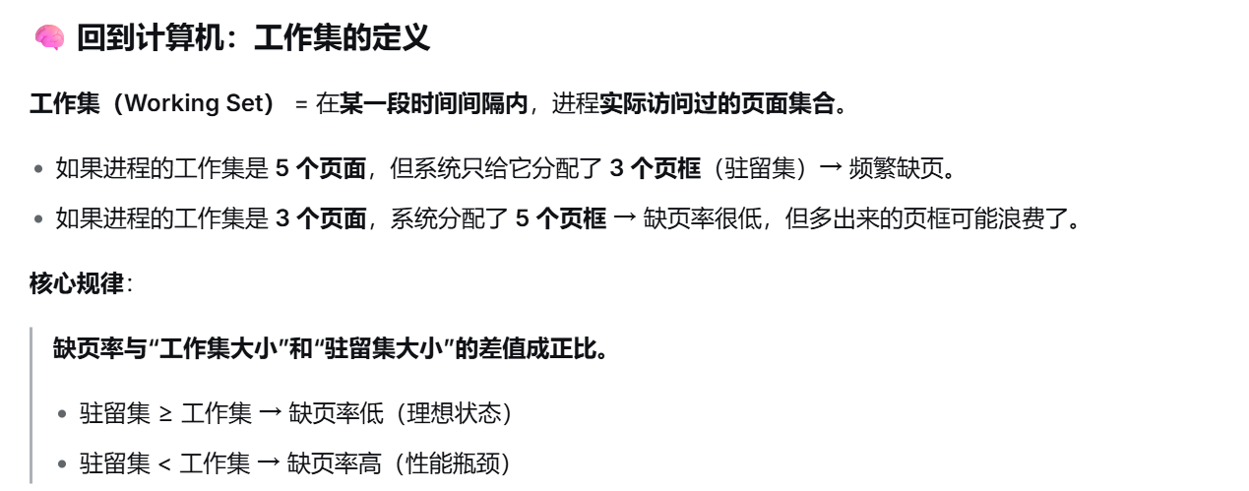
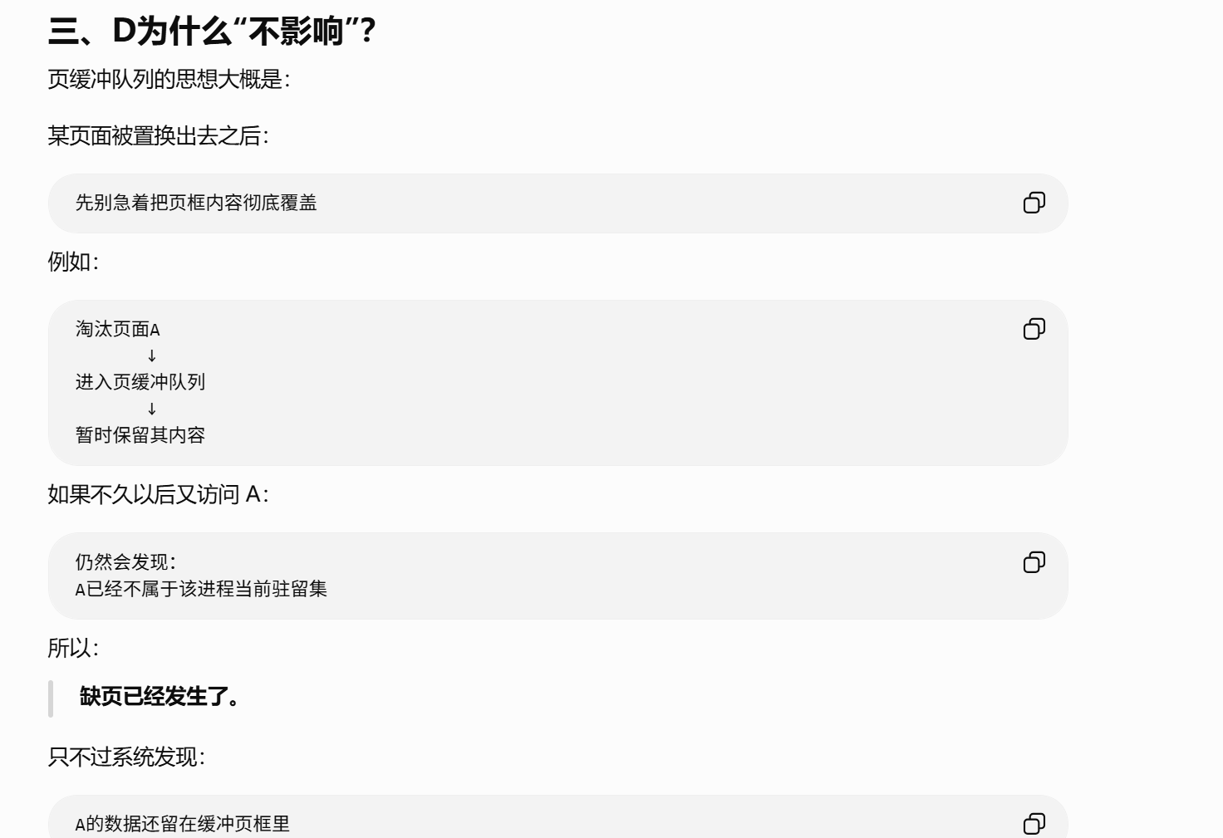
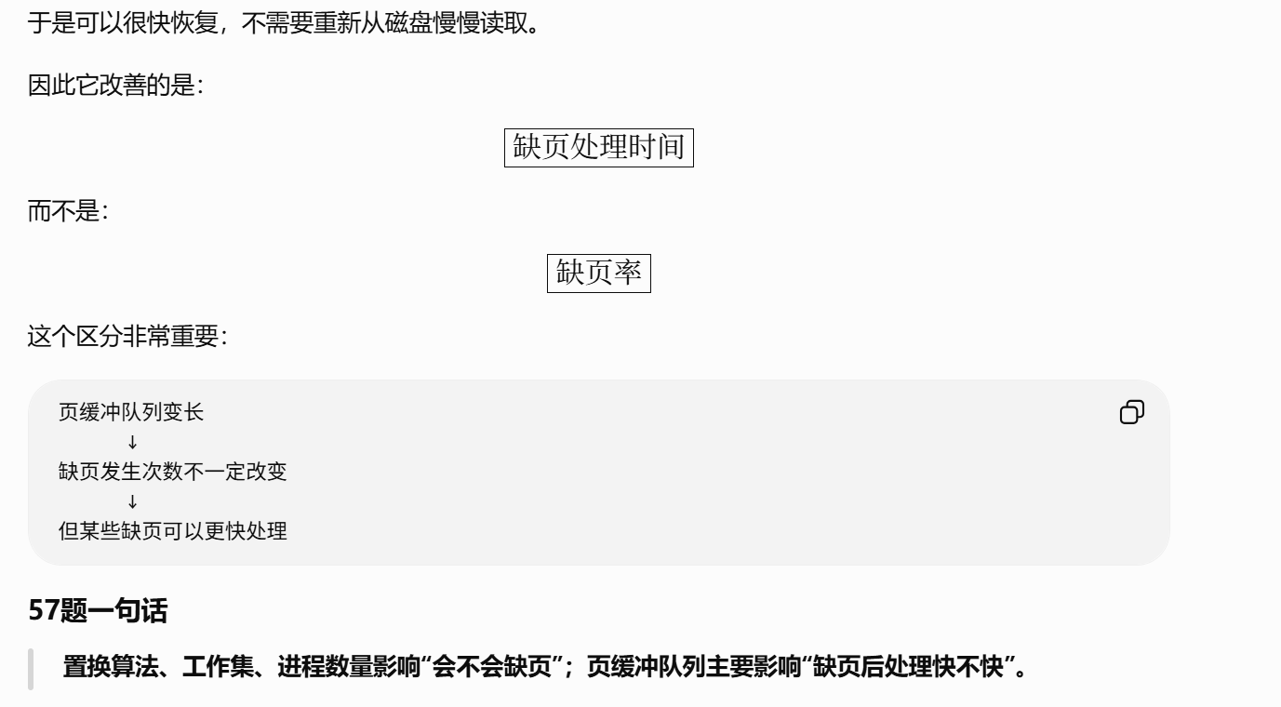

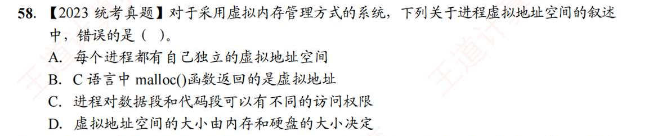
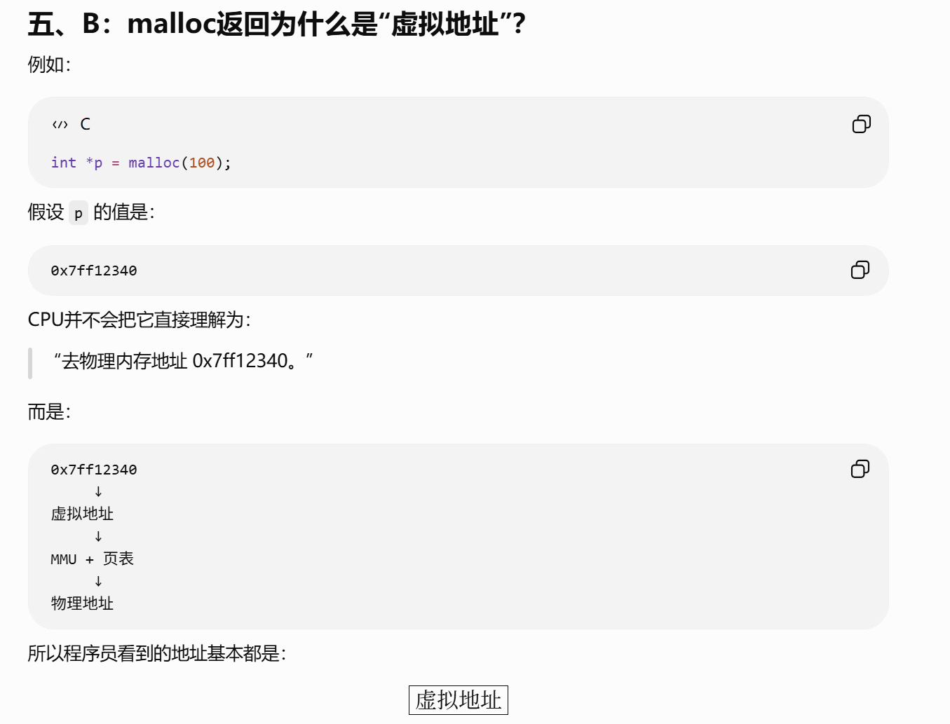
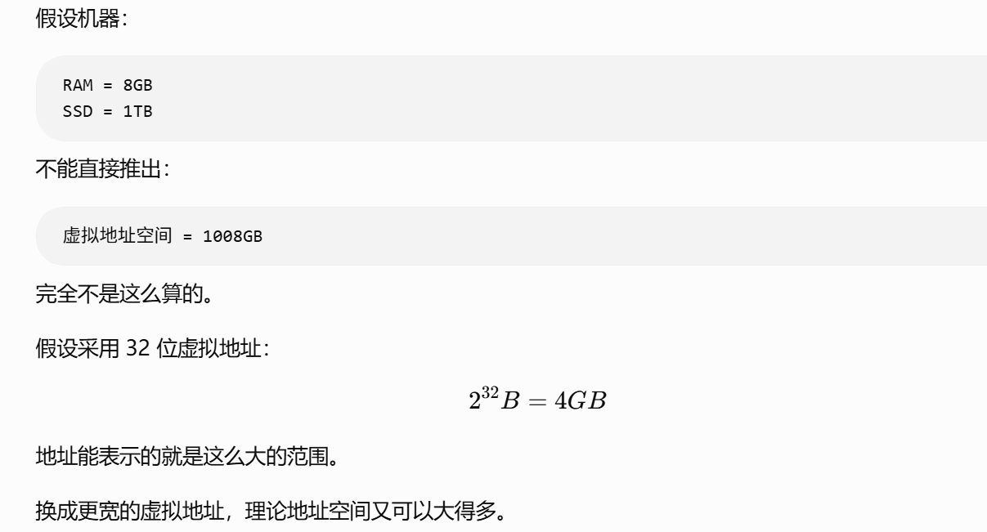

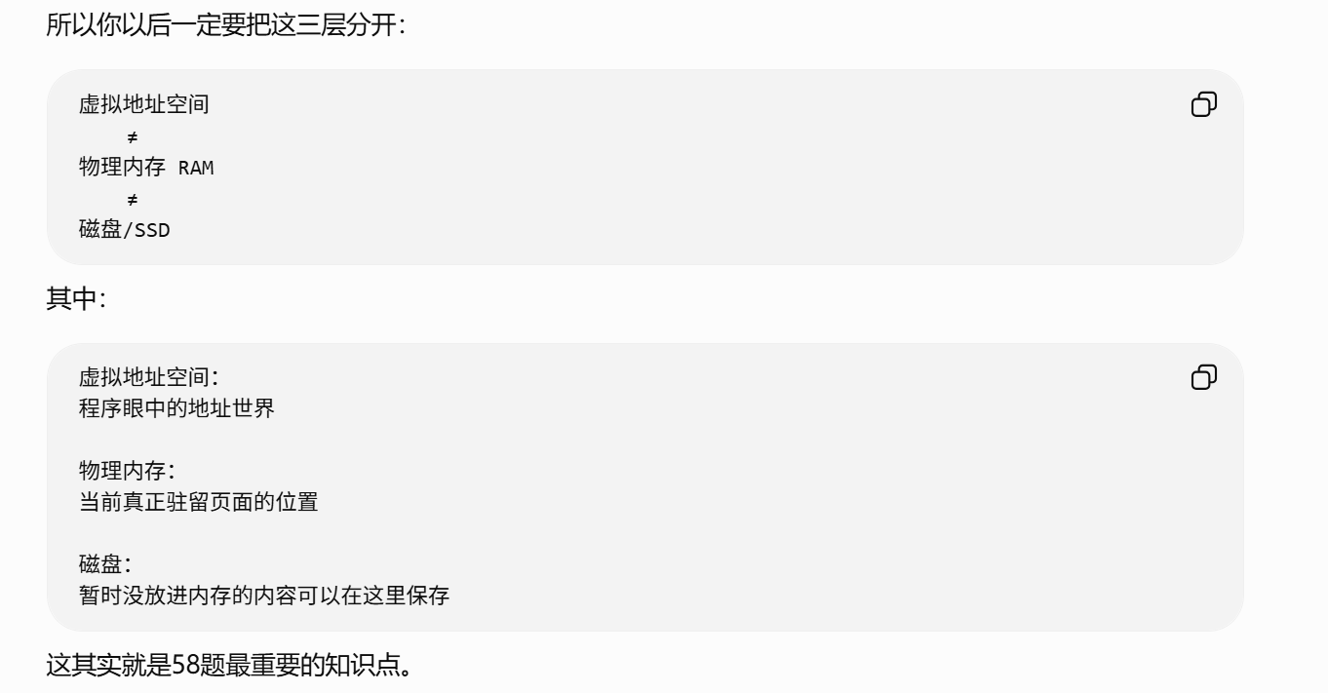

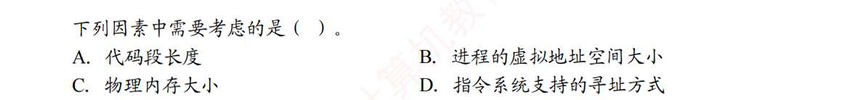
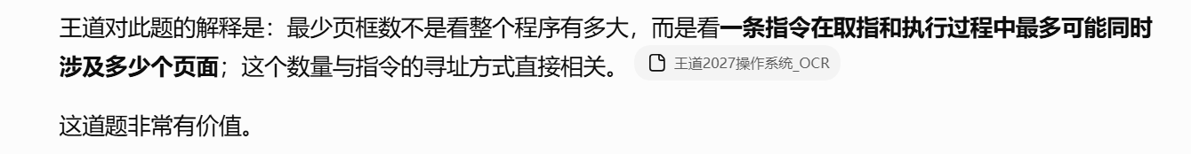
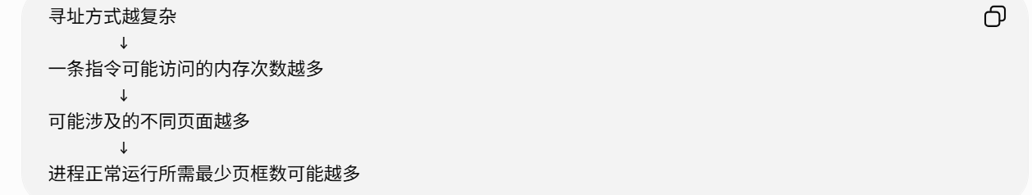
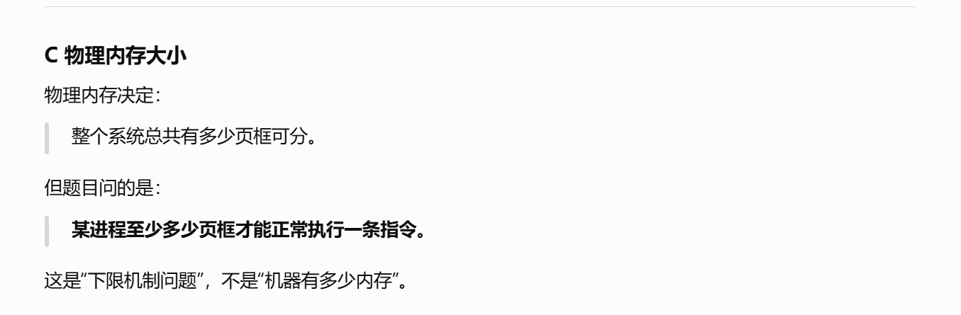
https://chatgpt.com/g/g-p-6a4147b6a8088191bef869eb87bbe5c0-cao-zuo-xi-tong/c/6a82f996-f0f4-83ee-8389-5d26a31d9629

计算：
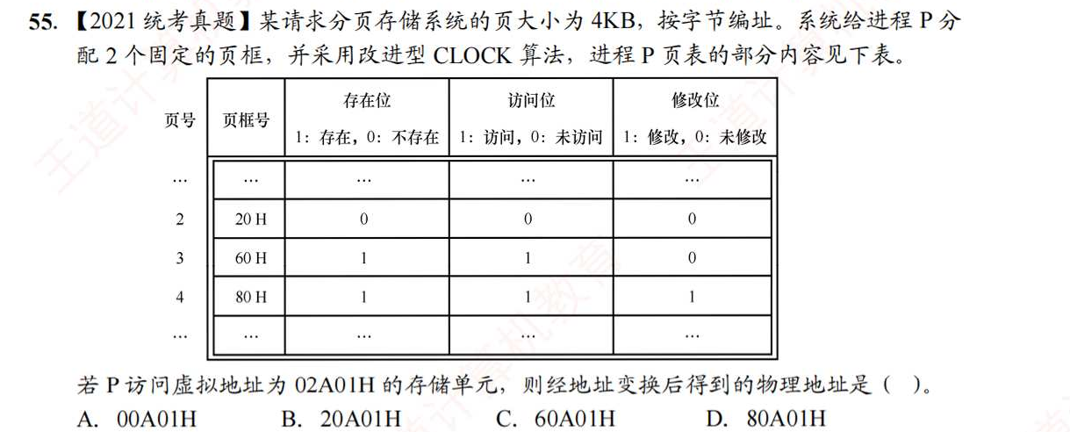
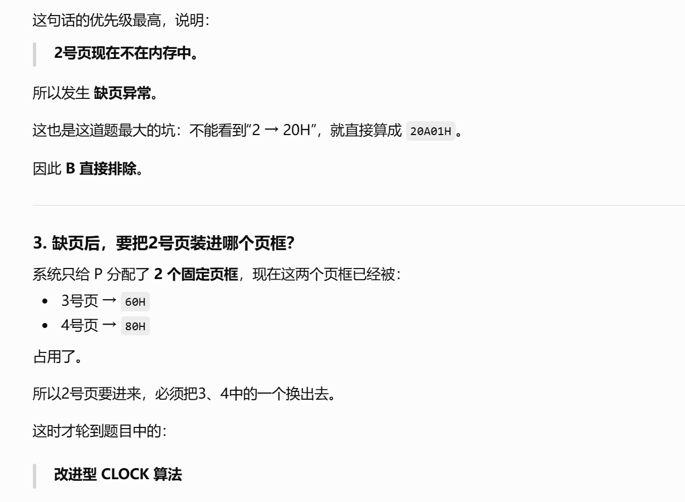
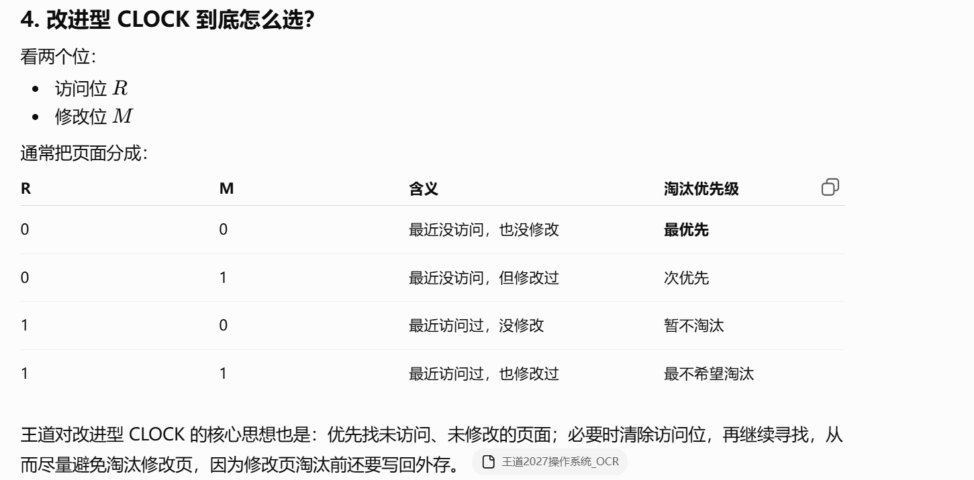
https://chatgpt.com/g/g-p-6a4147b6a8088191bef869eb87bbe5c0-cao-zuo-xi-tong/c/6a82fa41-9928-83ee-afe3-888038917759
|（注：部分内容可能由 AI 生成）

